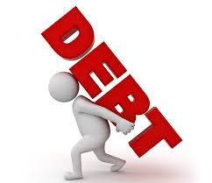
Canadians and Debt Assignment

Directions: Answer the following questions directly in this document using a different font colour. Use full and complete sentences. Please send your completed assignment through email as an attachment.

- Define debt (1)

- Explain how the term credit is related to debt. (1)

- Provide two types of debt that might be considered “good debt” and two types of debt that might be considered “bad debt”. Briefly explain why each would fall under that category. (4)

- Read the article titled “Canadians' average debt load now up to $22,081, 3.6% rise since last year”. Identify the main idea of the article and three key points to support this main idea. (4)

- Choose one article related to consumer debt from the Financial Post. In a short paragraph, summarize the article. Be sure to include a proper topic sentence that includes the title of the article and the main idea! (5)

- There are many organizations out there to help individuals who have problems with debt and credit. Visit the link to explore just one of those here in Winnipeg.
  - What has this organization identified as some of the physical/emotional effects of worrying about debt? (2)

  - What can this organization help you do? (2)

