Financial Literacy 21G
Name:

Forms of Money
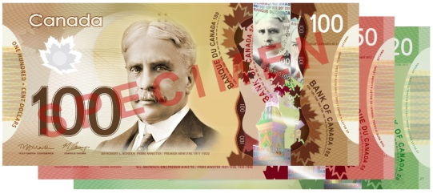
PART A: Bank Notes (20 points)
Use the following link (http://www.bankofcanada.ca/banknotes/) to answer the questions below:

- Who designs Canada’s bank notes? (1)

- Why did they switch from paper to the new polymer material? Provide at least two different reasons in your answer please. (2)

- What is counterfeiting? Is this good or bad for our economy? Explain your answer. (3)

- Why are our bank notes different colours? (1)

- Complete the following chart on the five denominations of bank notes produced in Canada (use the latest issue of the polymer bills): (5)

Denomination | Colour | Front Image | Back Image
$5
$10
$20
$50
$100

Use the following link (http://www.mint.ca/store/mint/learn/history-timeline-4000020) to answer the questions below:

- In what year was the first coin produced in Canada? (1)

- In what year was the loonie first introduced? Why did they create this to replace the $1 bank note? (2)

- The Canadian Mint is a world leader when it comes to patented technology. What is a patent? (1) Name one technology patent our Mint owns. (1)

- When did the Canadian Mint stop circulating the penny? (1) Why? (1)

- What will happen to cash transactions now that the penny is out of circulation? (1)

PART B: Cheques (14 points)
Complete the following two activities:

- Click the following link to learn more about cheques: http://www.edu.uwo.ca/interactives/Cheques/index.html . Complete all of the activities up until the point where it asks you to print. Before you write and submit your first answer, add your name to the text box so we can identify your printout.
Attach this printout to the back of this assignment.(10)

- Let’s pretend I do take bribes for A’s. Write me a cheque for all of your BaraniukBucks™ to find out! (4)
*Hint: You’ll have to do this question after you have printed out your assignment!

PART C: Debit Cards (6 points)
Answer the following questions related to debit cards:

- Explain why debit cards are called debit cards. (1)

- List at least two things you can do to protect yourself against debit card fraud. (2)

- Is there a cost to withdraw money from an Automated Banking Machine (ABM)? Explain. (2)

- Name one thing the banking industry is trying to do in order to make debit cards more secure. (1)

